IFRS 9 Week 3

Big picture: Basel, IFRS 9, and CECL
These three frameworks are often mixed together, but they serve different jobs inside a bank.
IFRS 9 is about provisioning — setting aside money for expected losses. Basel is about capital adequacy — holding capital for unexpected losses. The two frameworks are related, but they solve different problems. CECL is the US GAAP counterpart discussed in the module.
Basel is about capital.
IFRS 9 is about provisioning.
CECL is the US expected-loss provisioning approach.
Framework | Main purpose | Simple idea
Basel | Capital adequacy | How much capital should the bank hold for unexpected loss?
IFRS 9 | Provisioning | How much expected credit loss should the bank recognize now?
CECL | US provisioning | The US counterpart in the expected-loss world.
Analogy
Think of Basel as the safety helmet, IFRS 9 as the insurance for likely damage, and CECL as the US version of the insurance logic.
IFRS 9 is the bank’s rainy-day fund for losses that are expected to happen. Basel is the stronger wall that protects the bank when something worse than expected happens.

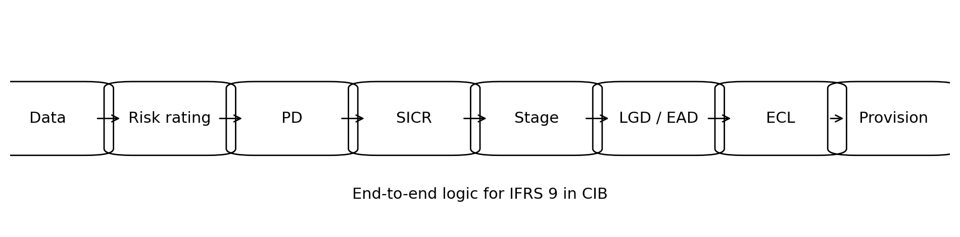

The big picture in CIB
In Corporate and Institutional Banking, IFRS 9 is not mainly about missed EMIs. It is about whether a corporate borrower is getting weaker, whether its default risk has increased, and how much loss the bank should recognise early through provisions.
The framework is the same as in retail, but the signals are different. In CIB, the bank watches internal risk ratings, covenant performance, financial ratios, account conduct, restructuring requests, and credit committee decisions.

Plain-English idea
Retail asks: 'Has the borrower missed payments?'
CIB asks: 'Has this corporate name become materially riskier compared with when we first booked it?'

Core mapping: Risk Rating -> PD -> Stage -> ECL
Step | What it means | CIB example | Why it matters
Risk rating | Internal view of borrower strength | BBB / BB / B grade | Feeds probability of default
PD | Likelihood of default over a period | 12-month PD or lifetime PD | Measures credit risk numerically
Stage | IFRS 9 risk bucket | Stage 1 / 2 / 3 | Decides the ECL horizon
ECL | Expected credit loss | PD x LGD x EAD | Becomes the provision

2. Which assets are inside the IFRS 9 impairment world
Not every asset is treated the same way. The key first step is to identify whether the instrument is in amortized cost, FVOCI, or FVTPL.
Asset bucket | IFRS 9 treatment | Learning point
Amortized cost | In scope for ECL | Most loan-loss provisioning work sits here.
FVOCI | In scope for ECL | Fair value changes exist, but credit loss still matters.
FVTPL | Outside impairment model | Measured through profit and loss, so the impairment story is different.
SPPI means solely payments of principal and interest. It is the cash-flow test that helps decide whether the asset belongs in the amortized cost / FVOCI family.
Analogy
SPPI is like checking whether a loan behaves like a plain vanilla loan or whether it has extra features that change the repayment nature.

3. Delinquency, DPD, and the bucket idea
Delinquency starts when a borrower misses a contractual payment date. DPD means days past due. The bucket idea is just a practical way of grouping lateness.
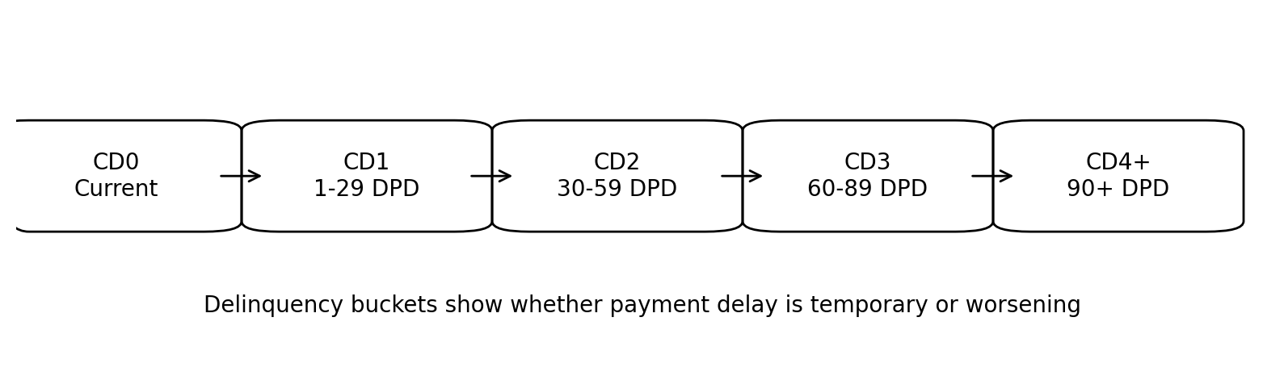
A bank uses these buckets to understand whether the delay is short-term noise or the start of a deeper credit problem.
Analogy
If a child misses one homework deadline, that is a delay. If the missed deadlines keep piling up, the teacher starts worrying about the student’s discipline. DPD works the same way for credit behavior.

4. Roll rate analysis
Roll rate analysis tracks how balances move from one bucket to another. It helps the bank see where balances recover, where they stay stuck, and where they keep rolling forward.
Movement | What it means | Why it matters
CD0 -> CD1 | A current account becomes slightly late | Early warning
CD1 -> CD2 | The delay is getting worse | Credit stress is building
CD2 -> CD3 | Balances are sticking in delinquency | Useful for bad-definition thinking
Analogy
Roll rate is like watching cars move through toll booths. If more and more cars keep entering the wrong lane and never return, that lane has a serious problem.

5. Delinquency, default, impairment, charge-off
These words are related, but they are not identical. Delinquency means late payment. Default means the bank believes the borrower has crossed a serious failure point. Impairment is the accounting view that expected loss has become material enough to require heavier provisioning.
Term | Plain meaning | Banking implication
Delinquency | Payment has been missed | The borrower may still cure
Default | Serious credit failure | Recovery becomes uncertain
Impairment | Credit loss is now expected | Provisioning becomes more conservative
Charge-off | Policy-driven removal from active book | Collections / recovery may continue
Analogy
Delinquency is being late. Default is the relationship turning bad. Impairment is the accountant saying the loss has to be recognized properly.

Default vs impairment vs delinquency
Term | Simple meaning | CIB interpretation
Delinquency | A payment is overdue | A contractual payment, interest, or principal is past due
Default | The borrower is unlikely to repay or has crossed a hard default rule | May involve insolvency, bankruptcy, major breach, restructuring, or severe past due
Impairment | The exposure is credit impaired | The bank believes recovery is materially weakened and Stage 3 applies

In practice, delinquency is one possible signal, default is the deeper credit event, and impairment is the accounting conclusion that follows the bank's policy and judgement.
In CIB, an exposure can be stressed long before it is technically past due.
That is why internal rating migration and committee judgement are often more important than a simple days-past-due count.

6. Staging logic
Staging is the engine of IFRS 9.
Stage 1 means the borrower is performing normally.
Stage 2 means credit risk has increased significantly.
Stage 3 means the exposure is impaired or default-like.
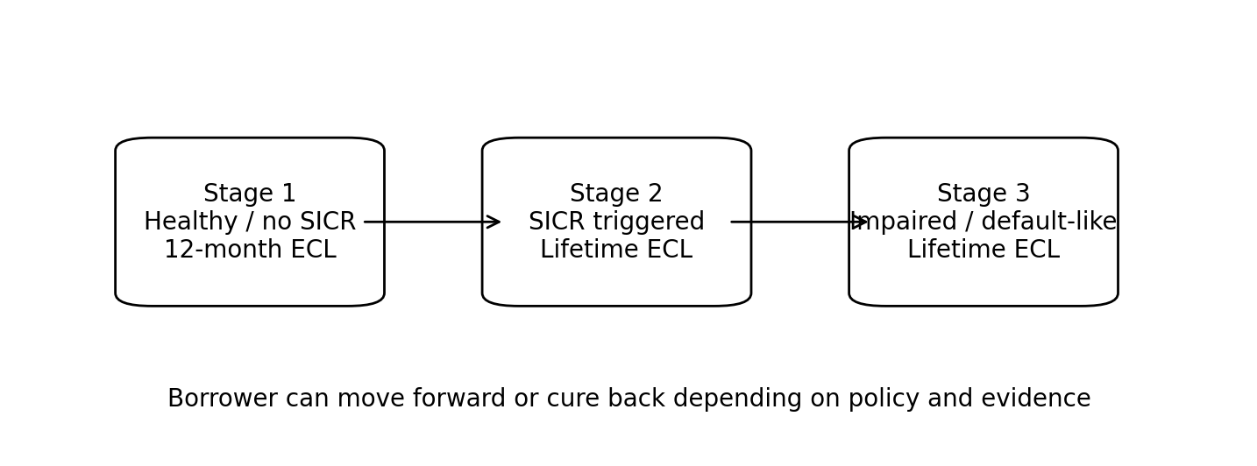
Stage | Meaning | ECL horizon
Stage 1 | No significant increase in credit risk | 12-month ECL
Stage 2 | SICR triggered | Lifetime ECL
Stage 3 | Impaired / default-like | Lifetime ECL with impairment focus

The staging logic in one simple framework
Stage 1 means the account is performing and has not shown a significant increase in credit risk since origination or since the last staging reset. For Stage 1, the bank books 12-month expected credit loss.
Stage 2 means the account is still alive, but credit risk has increased significantly. The bank now books lifetime expected credit loss because the borrower has moved into a higher-risk zone.
Stage 3 means the account is credit impaired or defaulted. At this point the borrower is no longer treated as a normal performing exposure, and the impairment is assessed much more aggressively.
Think of it like this
Stage 1 = healthy borrower
Stage 2 = borrower showing warning signs
Stage 3 = borrower has crossed into default / impairment

7. SICR: significant increase in credit risk
SICR is the bridge from Stage 1 to Stage 2. A common way to think about it is to compare the current behavioral PD with the PD at origination.
SICR lens | What it asks | Why it matters
Absolute threshold | Has PD moved by a meaningful amount? | Useful when risk levels are comparable
Relative threshold | Has PD moved by a meaningful percentage? | Useful when starting PDs vary a lot
Backstop rule | Has the borrower crossed a hard warning point? | Prevents obvious stress from being missed
Analogy
The borrower is still walking, but now the pace is slowing and the breathing is heavier. That is not default yet, but it is no longer healthy either.
In CIB, SICR is often influenced by rating downgrade, covenant breach, restructuring, watchlist status, sector weakness, and management judgment. It is not only about a missed payment.
SICR stands for Significant Increase in Credit Risk. In CIB, it usually does not come from a single missed instalment.
It is often inferred from a combination of rating downgrade, weakening financials, covenant stress, late information submission, increased utilisation, negative industry trends, or a credit committee concern.
The key idea is comparison.
The bank compares the borrower's current risk position with the position at origination.
If the current position is materially worse, the account may move from Stage 1 to Stage 2.
This is why CIB staging is judgement-heavy.
Two borrowers can both still be paying on time, but one may already be moving into Stage 2 because the business has deteriorated faster.

Absolute vs relative threshold
Absolute view: 'Has the rating fallen below a bank-defined cut-off?'
Relative view: 'Has the current PD moved sharply above the origination PD?'
Backstop view: 'Has the exposure crossed a hard warning rule such as 30 DPD or another policy trigger?'

8. Expected credit loss: PD, LGD, and EAD
The simplest formula is ECL = PD x LGD x EAD, with discounting and scenario weighting where relevant. PD is the chance of default, LGD is the share of loss if default happens, and EAD is the exposure outstanding when default happens.
Component | Meaning | Example
PD | Probability of default | Chance the borrower fails in the chosen horizon
LGD | Loss given default | How much is lost after collateral and recoveries
EAD | Exposure at default | How much money is at risk when the event happens
Analogy
PD tells you whether the roof might leak. LGD tells you how much damage the leak causes. EAD tells you how much furniture is under the roof.
Discounting matters because a loss that is expected one year later is not the same as a loss today. The bank therefore brings future loss back to present value.
Why the formula matters
A low PD borrower can still create large ECL if EAD is large.
A high PD borrower can still create moderate ECL if collateral reduces LGD.
A long-dated exposure can create higher lifetime ECL because risk has more time to build.

CIB-specific mapping: Risk Rating -> PD -> Stage -> ECL
In corporate and institutional banking, the workflow usually starts with the internal risk rating. That rating maps to PD. The PD then helps identify SICR, which drives the stage. Stage chooses the ECL horizon.
Risk-rating view | Typical banking interpretation | IFRS 9 direction
Strong rating | Low default risk | Usually Stage 1
Rating weakens | Risk has increased | Possible Stage 2
Default / workout | Serious credit failure | Stage 3 likely
Analogy
The rating is like a doctor’s vital sign reading. PD is the risk estimate. Stage is the diagnosis. ECL is the financial impact of the diagnosis.

10. Corporate borrower example
Imagine ABC Engineering Ltd. At origination it has a healthy rating, a low PD, and Stage 1 status. A few months later it misses an interest payment, submits delayed financials, and breaches a covenant.
The credit committee reviews the case and downgrades the internal rating. That rating movement pushes the PD higher. If the deterioration is judged significant, the account moves into Stage 2 and lifetime ECL becomes relevant.
Event | What the bank sees | Possible stage effect
Origination | Healthy rating and low risk | Stage 1
Covenant breach | Credit quality is weakening | SICR signal
Watchlist / downgrade | Deterioration is confirmed | Stage 2 likely
Workout / default evidence | Serious recovery concern | Stage 3 possible

11. Credit committee judgment and governance
CIB IFRS 9 is not only model-driven. Credit committee decisions can trigger watchlist placement, rating downgrade, restructuring approval, or a confirmed belief that the stress is temporary.
Committee action | What it means | Why it matters
Rating downgrade | Higher risk view | Can trigger SICR
Watchlist placement | Formal early warning | Supports closer monitoring
Restructuring | Borrower needs relief | May push the exposure to Stage 2 or Stage 3
Temporary forbearance accepted | Problem may be short-lived | May avoid over-staging if evidence is strong
Analogy
The model is the map, but the credit committee is the navigator. If the road is blocked, the navigator decides whether to reroute or stop.

12. Macro-economic layer
IFRS 9 is forward-looking. That means the bank should not only look at what already happened. It also needs to think about how the future environment may affect borrower behavior.
Macro factor | Possible effect | Why it matters
Interest rates | Debt service burden rises | PD may increase
Industry slowdown | Revenue pressure | Borrowers may weaken together
Liquidity stress | Refinancing becomes harder | Stages may move faster
Currency or commodity shock | Margins are squeezed | Recovery quality may fall

13. Worked ECL example
Suppose a corporate borrower has a 50 million exposure.
The current stage is Stage 2. The lifetime PD is 18 percent, the LGD is 35 percent, and the EAD is 50 million.
ECL = 50,000,000 x 18% x 35% = 3,150,000.
That is the gross expected loss before any further scenario or discounting adjustments.
Item | Value | Meaning
EAD | 50,000,000 | Exposure at default
PD | 18% | Lifetime chance of default
LGD | 35% | Loss severity after recovery
ECL | 3,150,000 | Expected credit loss
Analogy
If there are 100 similar baskets and 18 are expected to fail, and if each failure loses about a third of the basket value, the expected loss is the product of those two ideas.

14. End-to-end flow

The full logic can be remembered as one chain: data feeds the rating system, rating feeds PD, PD helps determine SICR, stage chooses the loss horizon, LGD and EAD turn the risk into money, and ECL becomes the provision.

